NULLIF Function

NULLIF function takes two paramenters and checks whether the supplied parameters are equal, return Null if they are equal, returns the First Parameter if they are not equal.

1. Click on File and select "New" => "Application"

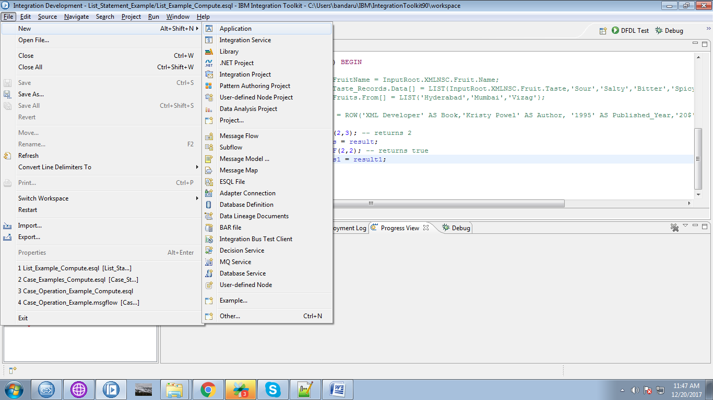

2. Give a name for your application and click "Finish " button.

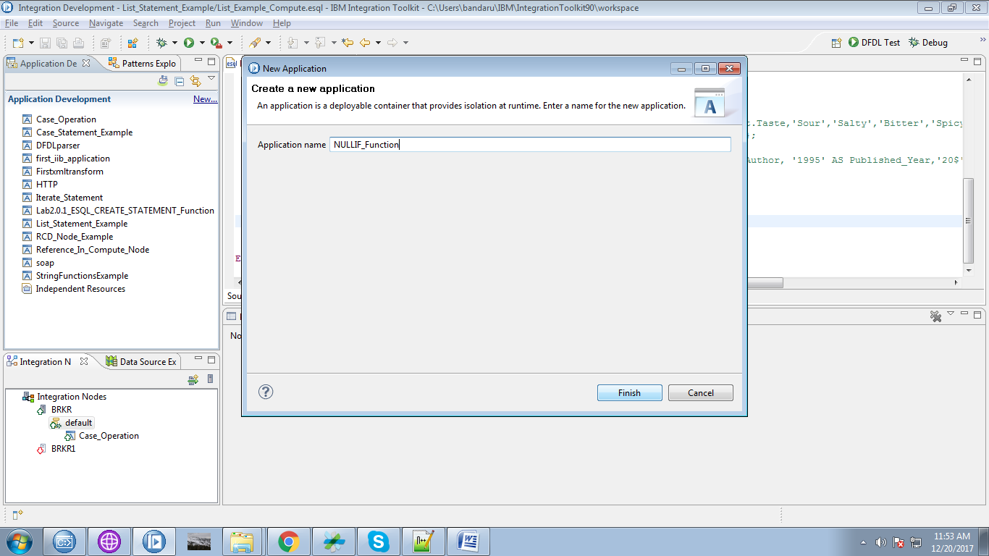

3. Under your application you can see "New" click on it.

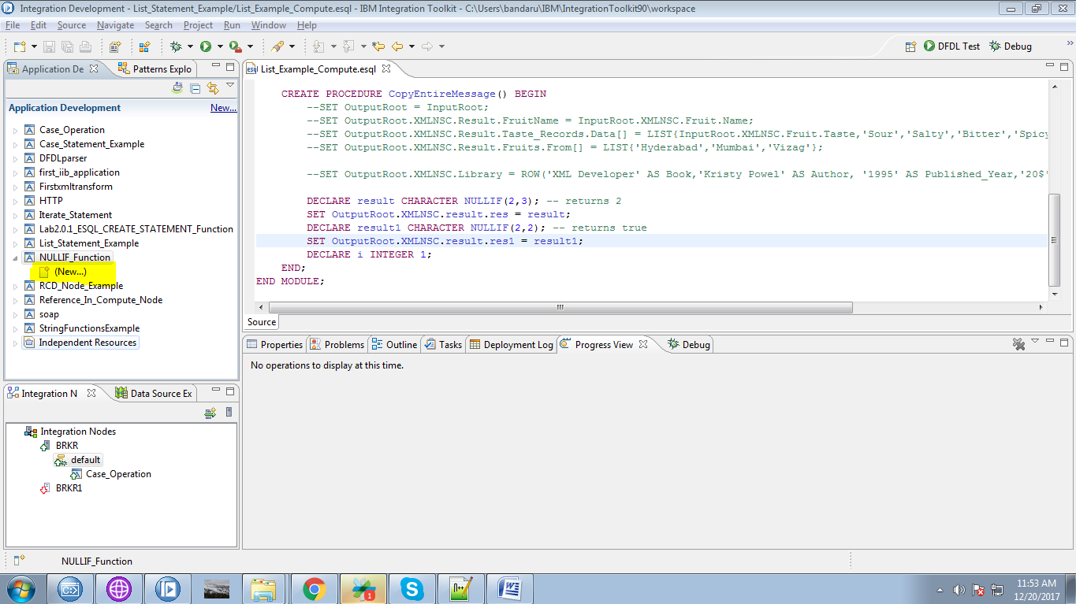

4. Select "Message Flow" from the given option.

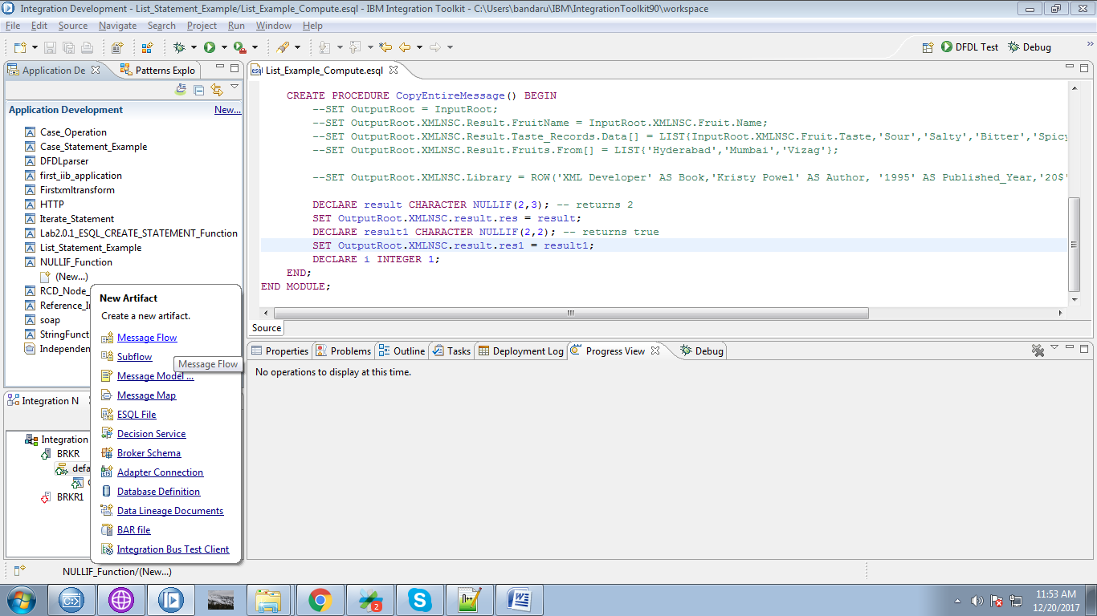

5. Give a name for your flow.

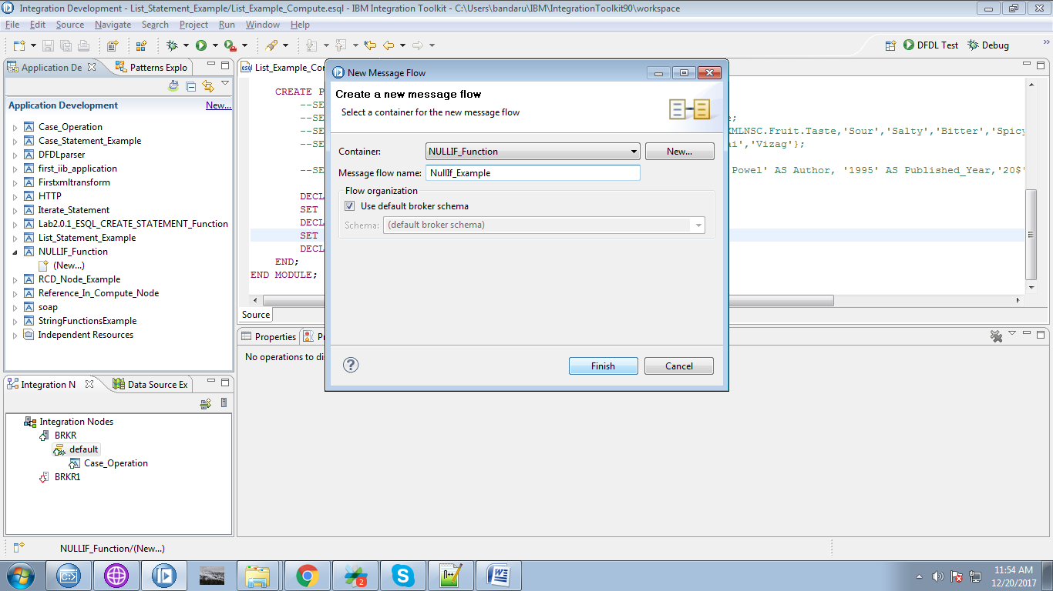

6. Drag the "MQInput" from the "WebSphere MQ" section and name it.

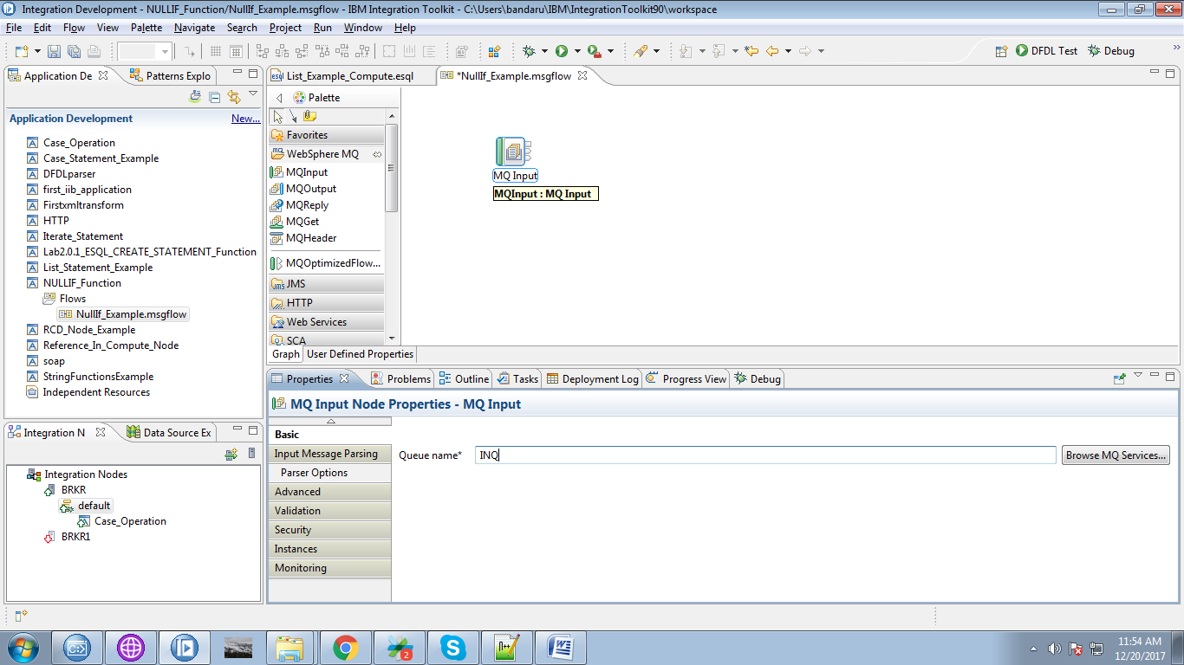

7. Drag the "Compute" node from "Transformation" section.

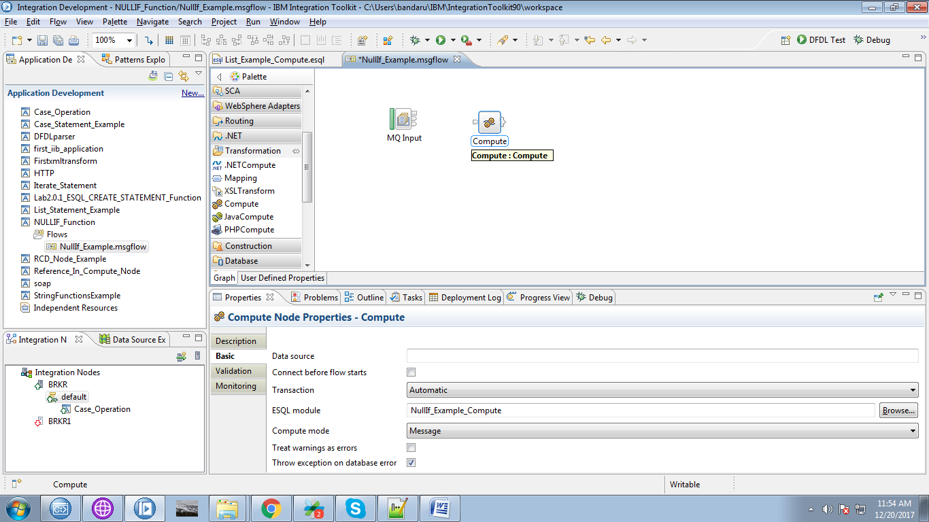

8. Connect the "output" terminal of the MQInput with the "input" terminal of the comput node.

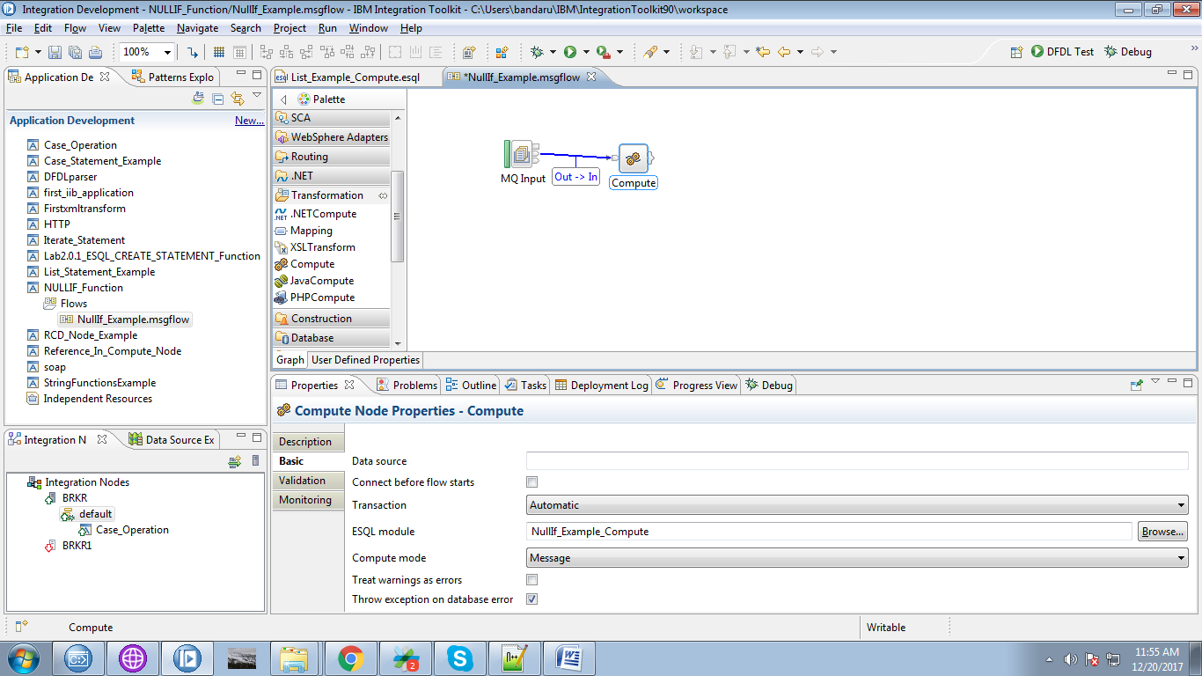

9. Drag the "MQOutput" from the "WebSphere MQ" and give it a name.

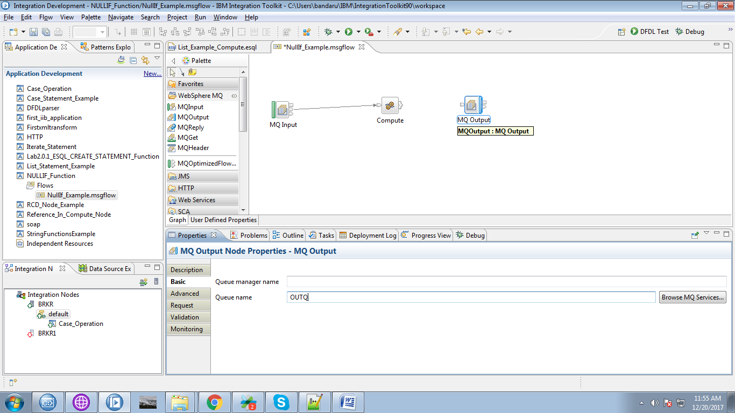

10. Click on output terminals of the compute node and select one of the terminal(Here i selected "Out") and click "OK" button.

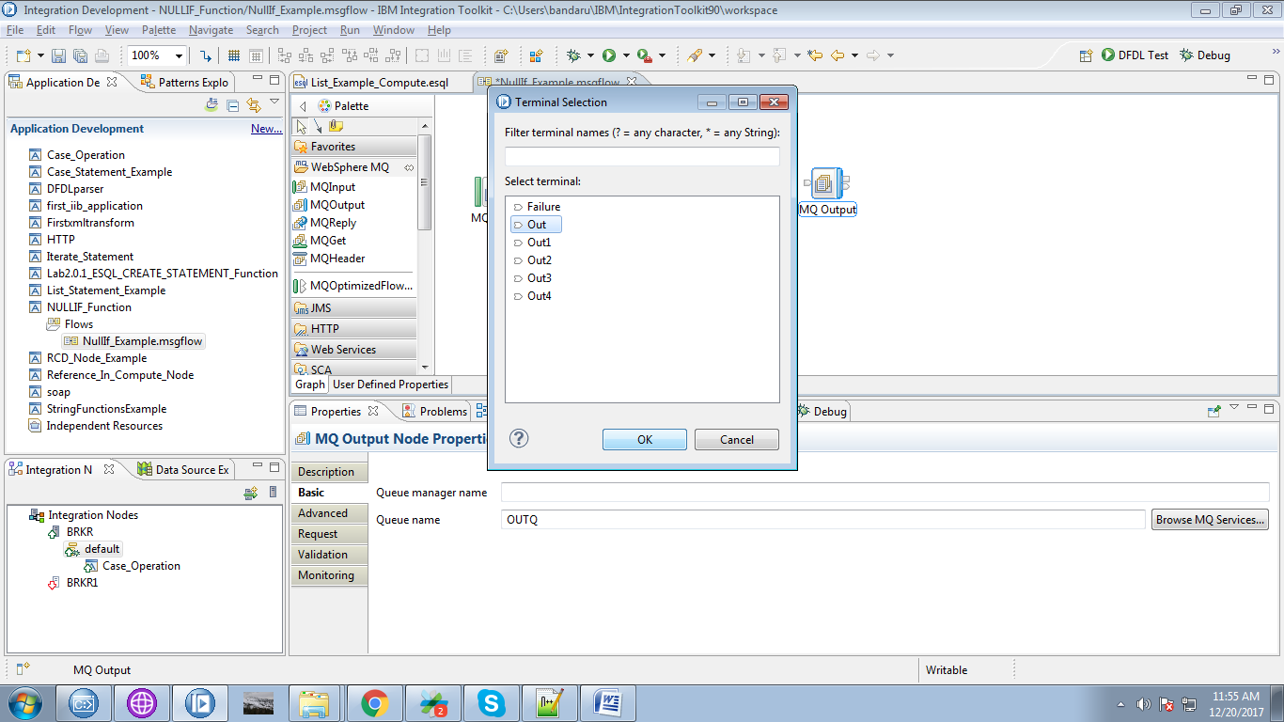

11. Connect "output" terminal of the compute node with the "input" terminal of the MQOutput.

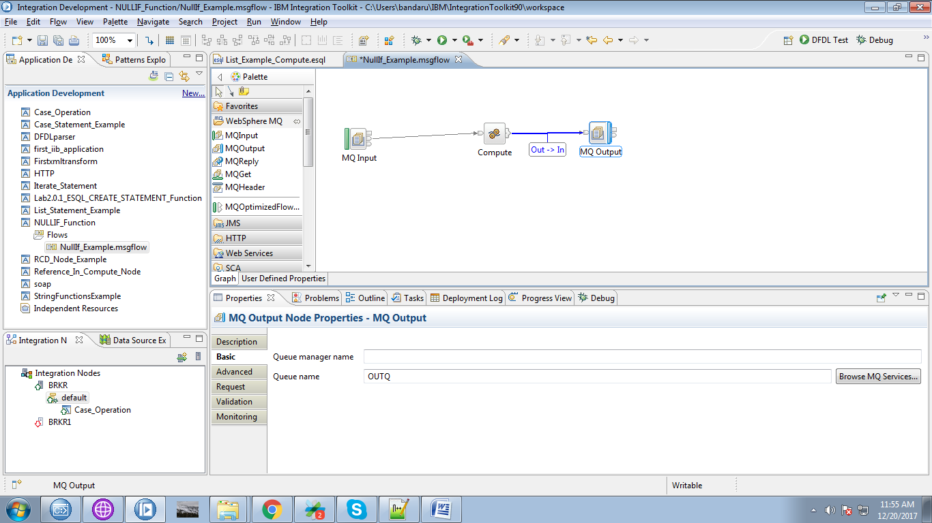

12. When you double click on compute node, following code will appears.

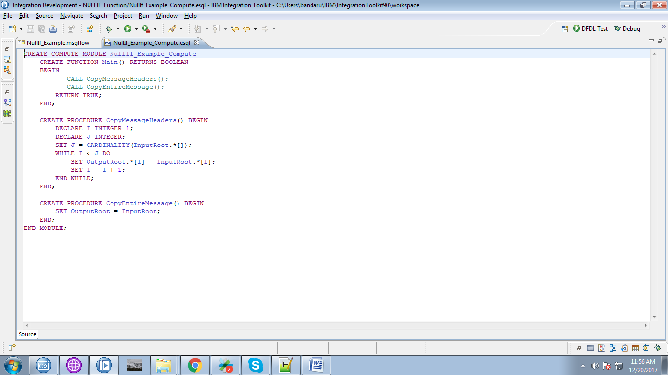

13. Override with following code.

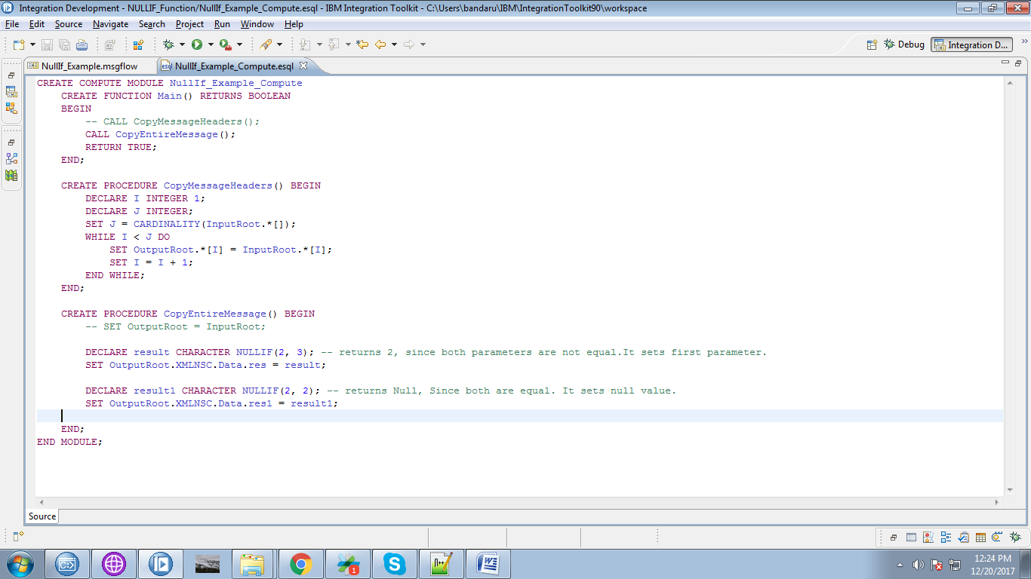

14. Right click on your application you can see "Deploy" option clck on it.

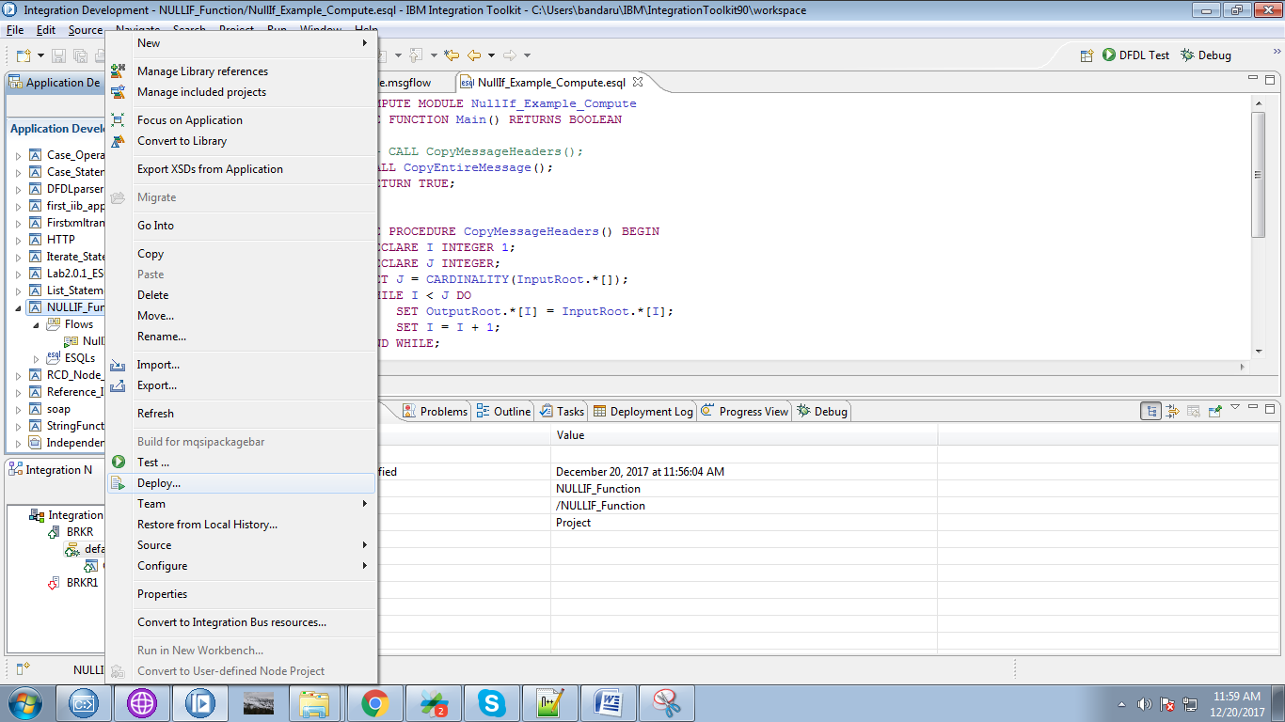

15. Select your broker and execution group and click "Finish" button.

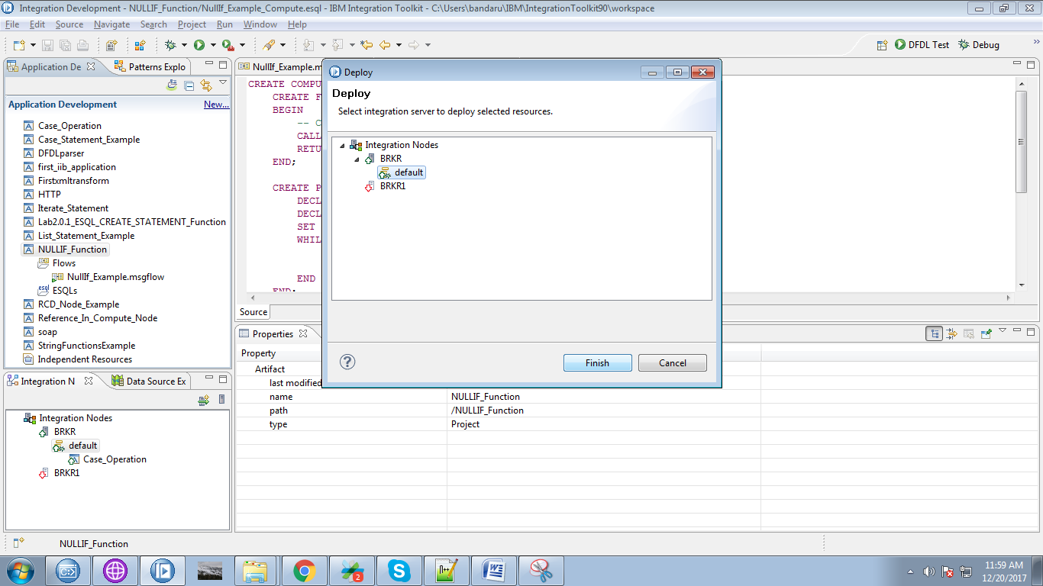

16. Create appropriate queues in "WebSphere MQ Explorer".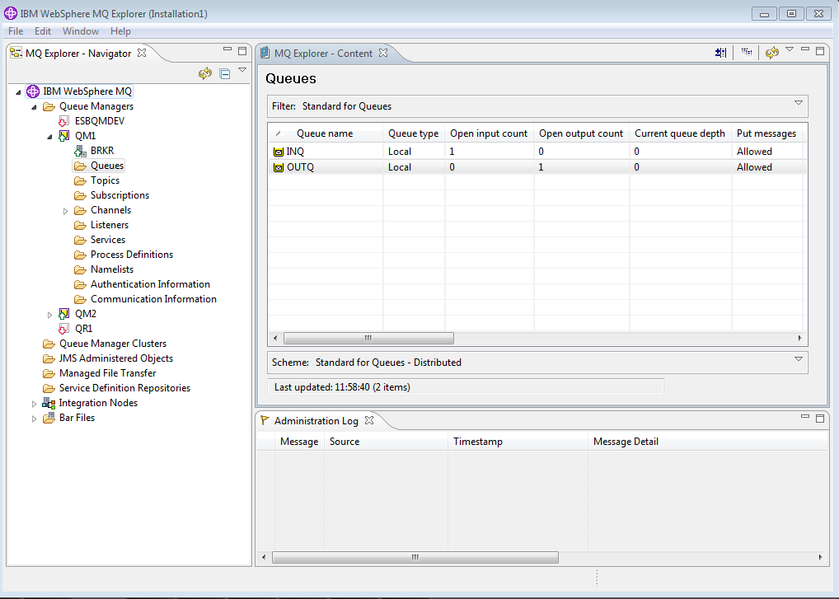

17. Right click on input queue and select "Put Text Message".

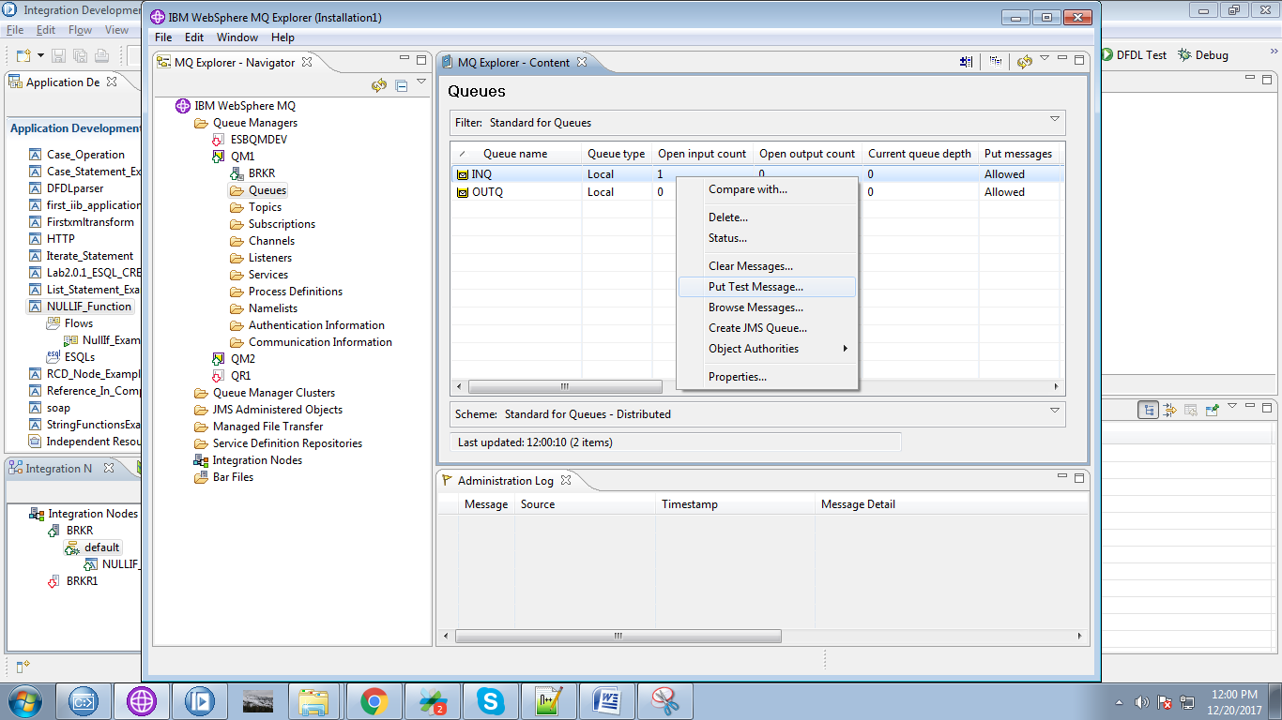

18. Give any dummy message to trigger your flow.

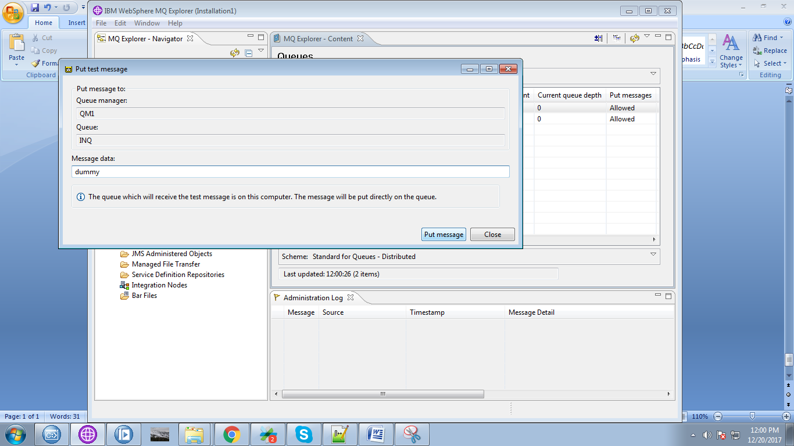

19. When you run your flow in debug mode.

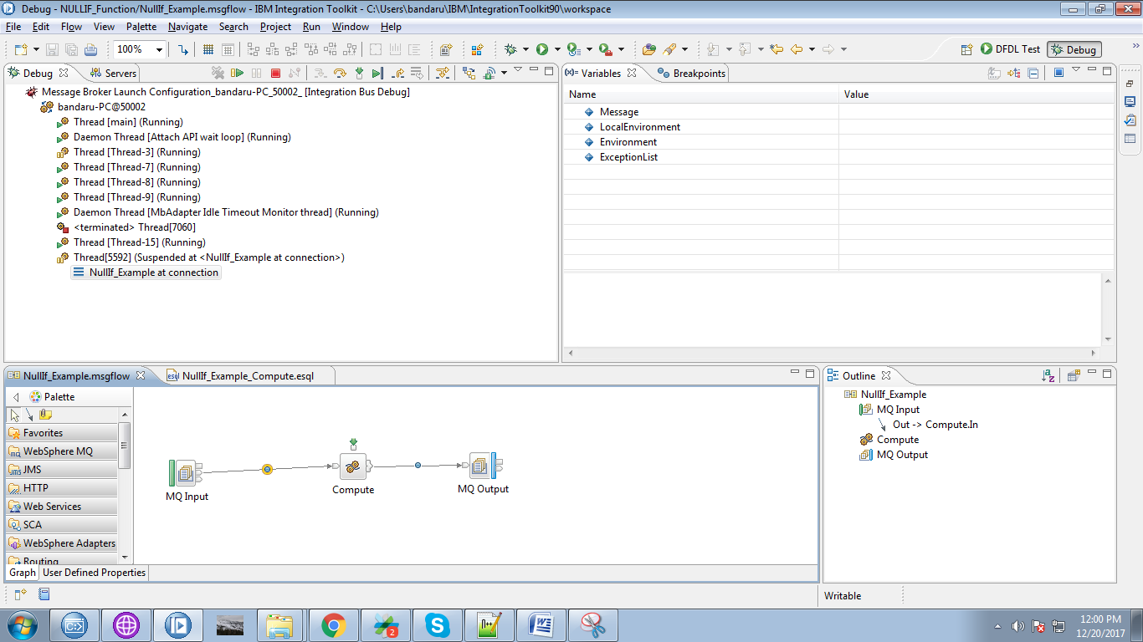

20. Here value "result" is set to "2" and "result1" is set as NULL.

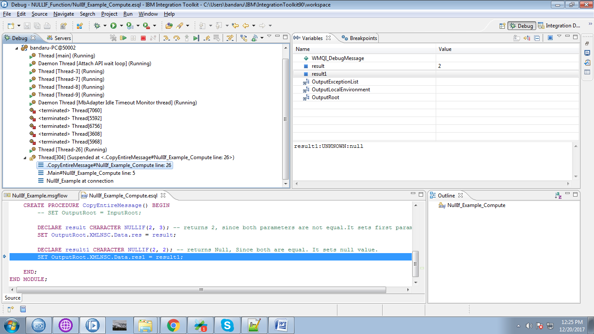

21. OutputRoot set when end of the compute node.

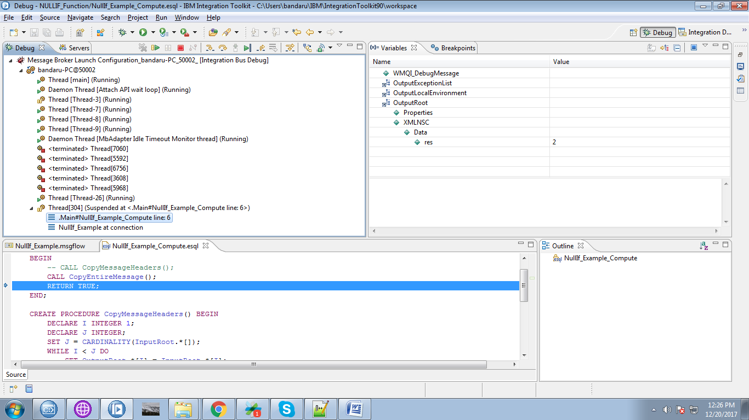

21. Output will go to MQOutput.

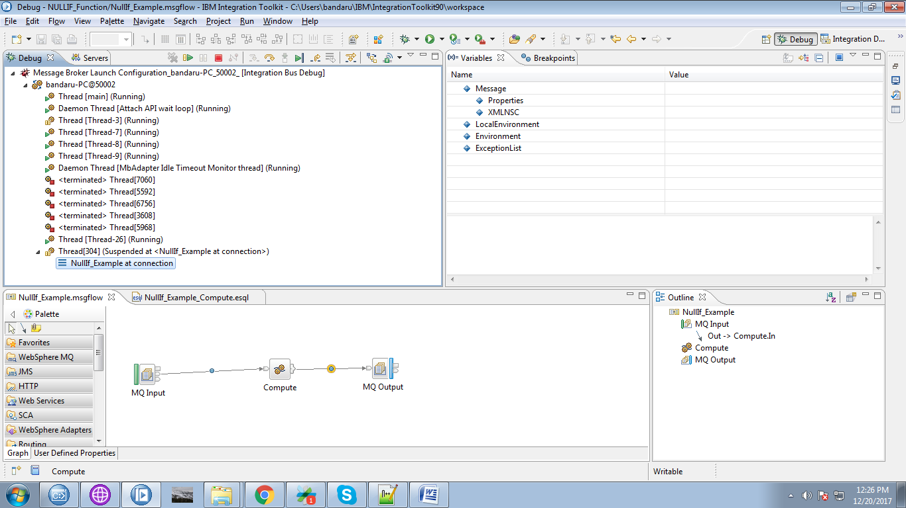

22. Right click on output queue and select "Browse Message".

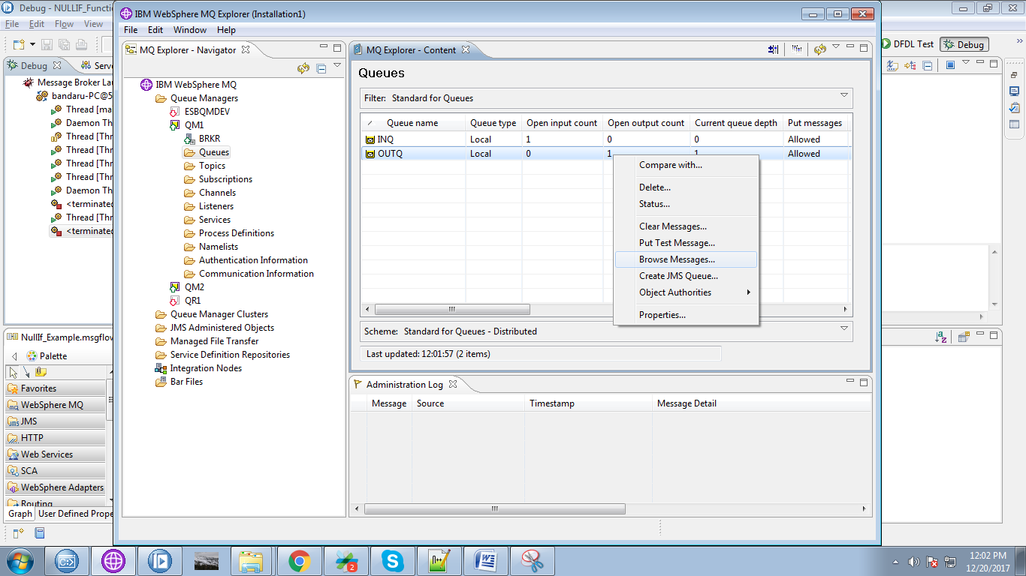

23. Right click on message and select "Properties".

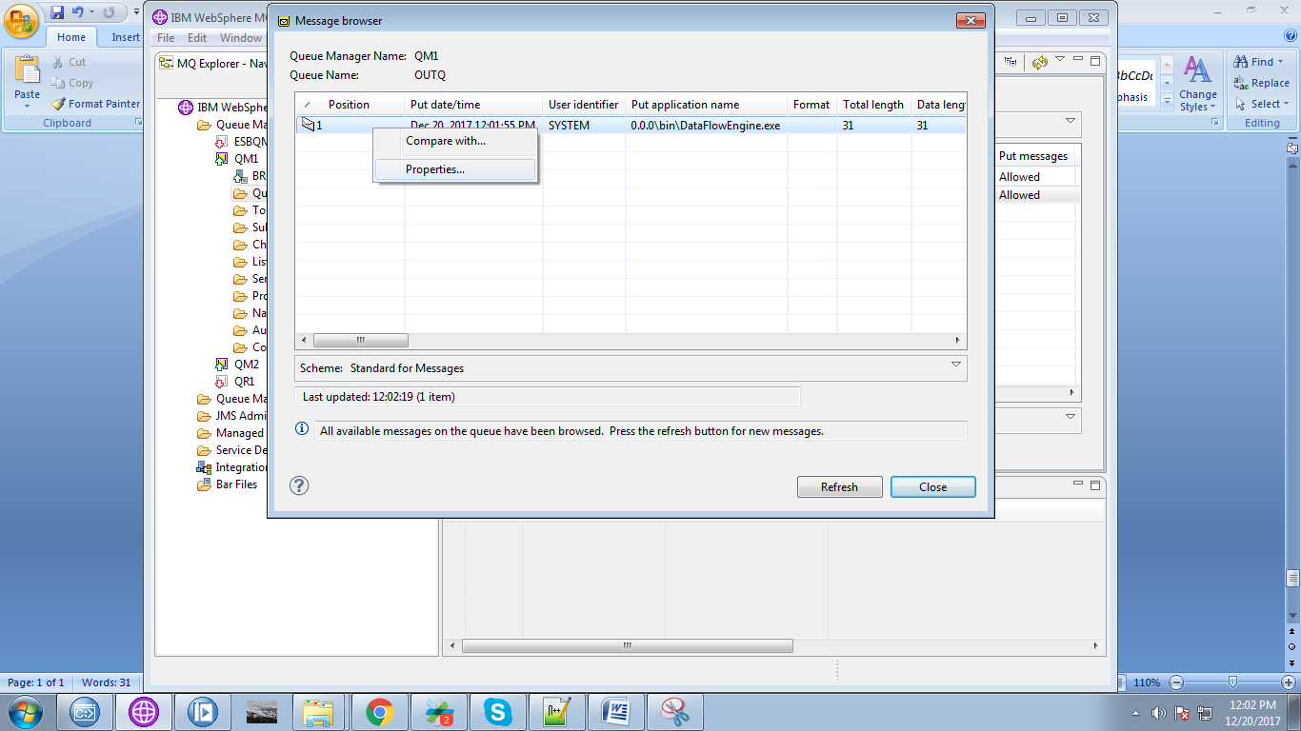

24. Final output can be seen in "Data" tab as below fig.

